

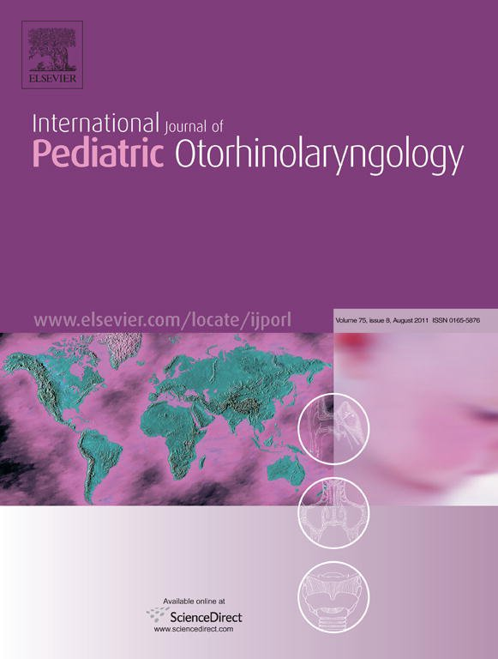

This article appeared in a journal published by Elsevier. The attached
copy is furnished to the author for internal non-commercial research
and education use, including for instruction at the authors institution
and sharing with colleagues.
Other uses, including reproduction and distribution, or selling or
licensing copies, or posting to personal, institutional or third party
websites are prohibited.
In most cases authors are permitted to post their version of the
article (e.g. in Word or Tex form) to their personal website or
institutional repository. Authors requiring further information
regarding Elsevier’s archiving and manuscript policies are
encouraged to visit:
http://www.elsevier.com/copyright
Author's personal copy

International Journal of Pediatric Otorhinolaryngology 75 (2011) 1020–1023


Contents lists available at ScienceDirect

International Journal of Pediatric Otorhinolaryngology

journ al hom epage: www.elsevier.com/locat e/ijpo r l

Branchial anomalies in children
*
Y. Bajaj , S. Ifeacho, D. Tweedie, C.G. Jephson, D.M. Albert, L.A. Cochrane, M.E. Wyatt,
N. Jonas, B.E.J. Hartley
Department of Otolaryngology, Great Ormond Street Hospital, Great Ormond Street, London LS17 7WA, United Kingdom

A B S T R A C T
A R T I C L E I N F O

Article history:
Received 5 April 2011
Received in revised form 7 May 2011
Accepted 9 May 2011
Available online 15 June 2011

Keywords:
Branchial
Children
Anomalies

Background: Branchial cleft anomalies are the second most common head and neck congenital lesions
seen in children. Amongst the branchial cleft malformations, second cleft lesions account for 95% of the
branchial anomalies. This article analyzes all the cases of branchial cleft anomalies operated on at Great
Ormond Street Hospital over the past 10 years.
Methods: All children who underwent surgery for branchial cleft sinus or fistula from January 2000 to
December 2010 were included in this study.
Results: In this series, we had 80 patients (38 female and 42 male). The age at the time of operation varied
from 1 year to 14 years. Amongst this group, 15 patients had first branchial cleft anomaly, 62 had second
branchial cleft anomaly and 3 had fourth branchial pouch anomaly. All the first cleft cases were operated
on by a superficial parotidectomy approach with facial nerve identification. Complete excision was
achieved in all these first cleft cases. In this series of first cleft anomalies, we had one complication
(temporary marginal mandibular nerve weakness. In the 62 children with second branchial cleft
anomalies, 50 were unilateral and 12 were bilateral. In the vast majority, the tract extended through the
carotid bifurcation and extended up to pharyngeal constrictor muscles. Majority of these cases were
operated on through an elliptical incision around the external opening. Complete excision was achieved
in all second cleft cases except one who required a repeat excision. In this subgroup, we had two
complications one patient developed a seroma and one had incomplete excision. The three patients with
fourth pouch anomaly were treated with endoscopic assisted monopolar diathermy to the sinus opening
with good outcome.
Conclusion: Branchial anomalies are relatively common in children. There are three distinct types, first
cleft, second cleft and fourth pouch anomaly. Correct diagnosis is essential to avoid inadequate surgery
and multiple procedures. The surgical approach needs to be tailored to the type of anomaly of origin of
the anomaly. Complete excision is essential for good outcomes.
ß 2011 Elsevier Ireland Ltd. All rights reserved.

1. Introduction
accepted theory is that they result from incomplete obliteration of
branchial clefts and pouches during embryogenesis [3].
Branchial anomalies represent 20% of cervical masses in
children. They are bilateral in 1% of the cases, without any
predilection to right or left side in unilateral cases [4]. Amongst the
branchial anomalies, second cleft lesions account for 95%. First cleft
anomalies account for 1–4% of these and third and fourth pouch
anomalies are rare [5]. This article analyzes all the cases of
branchial anomalies operated on at Great Ormond Street Hospital
over the past 10 years.

2. Patients and methods

This study was conducted at the paediatric ENT department at
Great Ormond Street Hospital, London, a tertiary paediatric referral
centre. All children who underwent surgery for branchial cleft
sinus or fistula from January 2000 to December 2010 were
included in this study.

Branchial cleft anomalies are the second most common head
and neck congenital lesions seen in children. They present as cysts,
fistulas, sinuses or cartilaginous remnants. The term branchial cyst
was first used by Ascherson in 1832(1). By the 4th week of
embryonic life, six branchial arches are recognisable. Five pairs of
ectodermal clefts (grooves) and five endodermal branchial
pouches separate these six arches, with a membrane located at
the interface between the pouch and the cleft [1].
Various theories proposed for the development of these
anomalies are branchial apparatus theory, cervical sinus theory,
thymopharyngeal theory and inclusion theory [2]. The most widely

* Corresponding author. Tel.: +44 7769686449; fax: +44 1132663305.
E-mail address: ybajaj@hotmail.co.uk (Y. Bajaj).
0165-5876/$ – see front matter ß 2011 Elsevier Ireland Ltd. All rights reserved.
doi:10.1016/j.ijporl.2011.05.008
Author's personal copy

Y. Bajaj et al. / International Journal of Pediatric Otorhinolaryngology 75 (2011) 1020–1023 1021
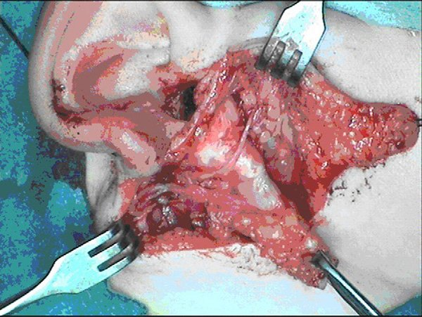
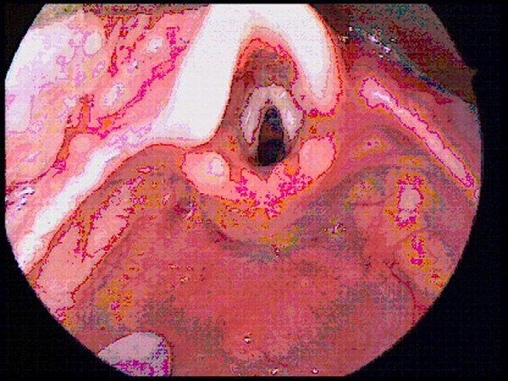

Fig. 3. Fourth arch sinus opening in left pyriform fossa.
Fig. 1. First arch fistula with facial nerve exposed.

The data were collected from patient records. The data collected
included patients demographics, type of branchial anomaly as
recorded by operating surgeon, operative details and their post
operative course. Also recorded were the complication and the
recurrences at follow up.

3. Results

In this series, we had 80 patients (38 female and 42 male). The
age at the time of operation varied from 1 year to 14 years.
Amongst this group, the branchial anomalies according to the type
were 15 first cleft, 62 second cleft and 3 fourth pouch branchial
anomalies.
In the subgroup of 15 children (8 male and 7 female) with first
branchial anomalies, the anomalies were on the right side in eight
cases and left side in six cases. Seven of these patients had
recurrent infections in the past and two of them had undergone
previous attempted excisions. One had undergone five previous
surgeries and another three. All these cases were operated on by a
superficial parotidectomy approach under general anaesthetic.
Facial nerve was identified in all these cases before fistula excision
(Fig. 1). In the majority of cases (12/15), the tract was a blind
ending sinus. In three cases, the tract was a fistula, opening into the
ear canal. In six cases the sinus tract was entirely deep to the facial
nerve, while in eight cases the tract was superficial to the main
trunk and branches of the facial nerve. In one case the fistula was
superficial to the lower division of the facial trunk and deep to the

Fig. 2. Second arch sinus being excised via elliptical incision.

upper division of the facial trunk. All these cases had macroscopic
evidence of skin or cartilage in the lining of the tract. Four of the
cases were completely duplicated ear canals with circumferential
cartilage lined with hair bearing skin. Complete excision was
achieved in all these cases. The majority of patients (12/15) stayed
in the hospital for one night and the other three for two nights. In
this series we had one complication (temporary marginal
mandibular nerve weakness). All these patients were followed
up in the clinic for at least 6 months post-operatively. Good
outcome was achieved in all these cases, and there were no
recurrences.
In the 62 children (30 male and 32 female) with second
branchial cleft anomalies, 50 were unilateral (34 right and 16 left)
and 12 were bilateral. The extent of the tract was variable in these
74 sinus/fistula tracts. In 6/74, the tract was short and extended
just up to sternomastoid muscle. In 14/74, the tract stopped short
of the carotid artery. In the vast majority (50/74), the tract
extended through the carotid bifurcation and extended up to
pharyngeal constrictor muscles in 44/74 and into tonsil fossa in 7/
74 cases. The majority of these cases (55/62) were operated on via
an elliptical incision around the external fistula opening under
general anaesthetic. Seven patients underwent a stepladder
incision (second separate horizontal incision) to excise the tract
completely. Complete excision was achieved in all cases except one
who required a repeat excision. A drain was inserted in only 13/62
cases. The majority of the patients stayed in the hospital less than
24 h (Daycase – 11, Overnight – 38, two nights – 11, three nights –
2). In this subgroup, we had two complications (3.2%) – one patient
developed a seroma and one had incomplete excision. Patients
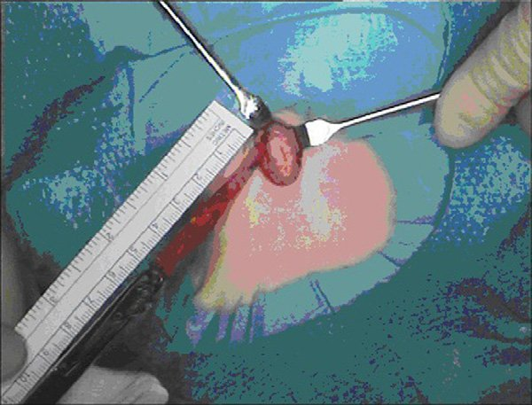
were reviewed in the clinic 6 weeks after the excision. Good
outcome was defined as complete excision of the disease and no
recurrence. This was achieved in all these patients (Fig. 2).
In this series, we had three patients with fourth branchial pouch
anomaly. All of them had a sinus opening in the left pyriform fossa
(Fig. 3), which was confirmed on microlaryngobronchoscopy
examination. They were all operated on less than 1 year of age.
These patients had monopolar diathermy applied endoscopically
to the sinus opening using a suspension laryngoscope and a
diathermy needle. They were observed in the hospital overnight. A
repeat laryngoscopy was performed 6 weeks later to confirm that
the sinus opening had sealed off. They were followed up in the
clinic and a good outcome was achieved in all these patients.

4. Discussion

Various terms have been used in the literature to describe
branchial anomalies. There are some important definitions which
Author's personal copy

1022 Y. Bajaj et al. / International Journal of Pediatric Otorhinolaryngology 75 (2011) 1020–1023

need to be clarified. A sinus is a blind ending tract. Sinuses arising are useful investigations to confirm the diagnosis and define the
from the branchial apparatus may connect with either the skin or extent of the lesion. The radiological appearances of branchial
the pharynx. Those connecting to skin are termed branchial cleft anomalies have been reported [14]. The scan may also help to
sinuses and those connecting with the pharynx are termed delineate the sinus tract or a deep seated cyst associated with the
branchial pouch sinuses [6]. Fistula, by definition is a communica- sinus tract. A scan can also be useful in evaluating the relation of
tion between two epitheliazed surfaces. A congenital branchial facial nerve to the first cleft anomaly. In the cases of suspected
fistula would require a communication between a persistent pouch fourth pouch anomalies, a sinogram or barium contrast study can
and a cleft. A pseudo-fistula may form between a pouch internally be useful [10]. In this series, majority of the cases had a scan done
and an external opening produced secondary to an infection or pre-operatively. All the first cleft anomalies underwent MRI scan.
iatrogenic. Surgical excision is the definitive treatment for branchial
Branchial anomalies can be divided into first cleft, second cleft, anomalies. These lesions do not regress spontaneously and have a
third and fourth pouch anomaly. The embryonic origin of these high rate of recurrent infections [15]. The reported recurrence rate
lesions ultimately dictates their presentation, diagnosis and after primary excision is 3%, but can be 14–22% after surgical
correct surgical treatment. Each branchial arch, poch and cleft excision after previous infection or previous incomplete excision
complex develops into specific structures in the head and neck [16]. Recurrences are usually seen with first cleft, third and fourth
region. The branchial anomaly and its associated tract lies inferior pouch anomalies [16]. The aim should be to achieve complete
to all the derivatives of its associated arch and superior to all surgical excision, preserving the normal structures.
derivatives of the next arch [7]. The ideal treatment for first cleft anomalies is by a superficial
The first cleft anomalies have been classified by Work into two parotidectomy approach with facial nerve exposure. All the cases
types on the basis of clinical features and histopathology [8]. Type I in this series were managed by this approach, with facial nerve
anomalies are purely ectodermal and present as a cystic mass. monitoring. The external appearance suggests a minor abnormali-
Histologically these have squamous epithelium, but no skin ty, however very significant cutaneous tract exists. Clinicians may
adnexa or cartilage. Type II anomalies present as a cyst, sinus or therefore easily underestimate the extent of the problem. Facial
fistula tract and are of ectodermal and mesodermal origin. These nerve injury is a major risk factor in the excision, especially so if the
on histology have squamous epithelium with skin adnexa or patient has a past history of multiple infections or incomplete
cartilage. surgical excisions [17]. Facial nerve injury was reported in 6 of the
The second branchial cleft anomalies are identified along the 39 cases by Triglia et al. [18] and 2 of the 5 patients by Ford et al.
anterior border of the sternomastoid muscle. The extent of the [19]. In this series we had temporary marginal mandibular
sinus or the location of the cyst can be anywhere along the course weakness in 1 out of 15 patients.
of the second branchial fistula, which proceeds from the skin of Second cleft sinuses/fistulas also need to be completely
neck, between the internal and external carotid arteries and into excised for good outcomes [7]. The usual approach is a
the palatine tonsil. The second branchial cleft sinuses/cysts are horizontal incision encompassing the external sinus opening
classified into four types by Bailey [9]. Type I is the most superficial and dissecting the sinus tract completely. Sometimes a second
and lies along the anterior surface of the sternomastoid muscle, incision is required for completing the excision. Similar
just deep to the platysma. Type II is the most common and is found approach was used in this series. Care must be taken to avoid
along the anterior surface of the sternomastoid, lateral to carotid injury to hypoglossal and vagus nerves [3]. In this series we had
space and posterior to submandibular gland. Type III extends good overall complications. We had two complications in the 62
medially between the bifurcation of the internal and external second arch patient subgroup- one had a seroma and an
carotid arteries to lateral pharyngeal wall. Type IV opens into the incomplete excision in another patient.
pharynx and is lined with columnar epithelium. Treatment of congenital fourth arch sinuses from historical
Most third and fourth pouch anomalies are sinuses and not times has been surgical, in the form of formal excision of the whole
congenital fistulae. A third branchial pouch sinus might originate sinus or fistula tract as well as thyroid lobectomy for thyroid
in the rostral end of pyriform fossa, would be most likely to pass involvement as curative treatment [20–23]. However due to the
cranial to superior laryngeal nerve before turning inferiorly anatomical course of the tract, complete resection remains
between the common carotid artery and the vagus nerve to end challenging [24,25]. Successful outcomes have been achieved
lateral to thyroid gland [10]. A fourth branchial pouch sinus would more recently by endoscopic techniques, which is reliable, quick
exit the hypopharynx, in a similar manner behind the thyroid ala, and simple with less post operative complications [26,27]. A
descending caudal to the superior laryngeal nerve and cranial to recent review of management of fourth branchial arch anomalies
the recurrent laryngeal nerve and terminating in the thyroid gland in children, recommended treatment with cauterisation rather
or parathracheal position [10]. Fourth branchial pouch anomalies than open neck surgery to reduce complications [22]. Recurrence
are extremely rare and constitute less than 3% of all branchial rates also were similar with both procedures. All three cases with
anomalies [11]. The consistent feature of these fourth branchial fourth pouch anomaly were treated with cauterisation with good
pouch anomalies is that they are predominantly (95–97%) left end result. There were no complications in this subgroup of
sided [12], and a clear reason for this is still not understood. It is patients.
thought to be due to the more complex and longer pathway of the Recurrence rates are increased when there are multiple
fourth branchial tract on this side compared with the right side. preoperative infections and when there is no epithelial lining
Some authors have suggested it is a result of asymmetrical vascular identified in the excised specimen [7].
agenesis during embryogenesis [13].
Correct diagnosis and appropriate surgical management of 5. Conclusions
these brachial anomalies depends on the understanding of
anatomy and high index of suspicion. The diagnosis of branchial Branchial anomalies are relatively common in children. There
anomalies depends on good history and examination in addition to are three distinct types, first cleft, second cleft and fourth pouch
having high index of suspicion and clinical awareness. Branchial anomaly. Correct diagnosis is essential to avoid inadequate surgery
anomalies should be suspected for any unexplained neck masses or and multiple procedures. The surgical approach needs to be
recurrent neck spaces infections. Evaluation of congenital neck tailored to the suspected arch of origin of the anomaly. Definitive
lesions is aided by radiological investigations [14]. CT/MRI scans excision is essential for good outcomes.
Author's personal copy

Y. Bajaj et al. / International Journal of Pediatric Otorhinolaryngology 75 (2011) 1020–1023 1023
References
[15] V.M. Vermeire, J.J. Daele, Second branchial cleft-pouch, fistulae, sinuses and cysts
in children, Acta Otorhinolaryngol. Belg. 45 (1991) 437–442.
[16] S.S. Choi, G.H. Zalzal, Branchial anomalies: a review of 52 cases, Laryngoscope 105
(1995) 909–913.
[17] R.G. McRae, K.J. Lee, E. Goertzen, First branchial cleft anomalies and the facial
nerve, Otolaryngol. Head Neck Surg. 91 (1983) 197–201.
[18] J. Triglia, R. Nicollas, V. Ducroz, P.J. Koltai, E.N. Garabedian, First Branchial cleft
anomalies – a study of 39 cases and a review of the literature, Arch. Otolaryngol.
Head Neck Surg. 124 (1998) 291–295.
[19] G.R. Ford, A. Balakrishnan, J.N.G. Evans, C.M. Bailey, Branchial cleft and pouch
anomalies, J. Laryngol. Otol. 106 (1992) 137–143.
[20] R. Nicollas, V. Ducroz, E.N. Garabedian, J.M. Triglia, Fourth branchial pouch
anomalies, Int. J. Pediatr. Otorhinolaryngol. 44 (1998) 5–10.
[21] K.D. Pereira, G.G. Losh, O. Dwight, M.D. Poole, Management of anomalies of the
third and fourth branchial pouches, Int. J. Pediatr. Otorhinolaryngol. 68 (2004)
43–50.
[22] K. Nicoucar, R. Giger, G.P. Harrison, T. Jaecklin, P. Dulgerov, Management of
congenital fourth branchial arch anomalies: a review and analysis of published
cases, J. Pediatr. Surg. 44 (2009) 1432–1439.
[23] M. Hamoir, P. Rombaux, A.S. Cornu, P. Clapuyt, Congenital fistula of the fourth
branchial pouch, Eur. Arch. Otorhinolaryngol. 255 (1998) 322–324.
[24] C. Yang, J. Cohen, E. Everts, J. Smith, J. Caro, P. Andersen, Fourth branchial arch
sinus: clinical presentation, diagnostic workup and surgical management, Laryn-
goscope 108 (1999) 442–446.
[25] H.S. Sharma, A. Razif, M. Hamzah, A.S. Dharap, Z. Mahbar, M.Z.M. Kamal, A.W.
Jantan, Y.N. Htun, Fourth branchial pouch cyst: an unusual case of neonatal
stridor, Int. J. Pediatr. Otorhinolaryngol. 38 (1996) 155–161.
[26] S.H. Evans, M. Marinello, K.M. Dodson, Novel presentation of a fourth branchial
cleft anomaly in a male infant, Am. J. Otolaryngol. 31 (2010) 120–122.
[27] N. Leboulanger, K. Ruellan, J. Nevoux, S. Pezzettigotta, F. Denoyelle, G. Roger, E.N.
Garabedian, Neonatal vs delayed onset fourth branchial pouch anomlaies:
therapeutic implications, Arch. Otolaryngol. Head Neck Surg. 136 (2010)
885–890.
[1] M. Mitroi, D. Dumitrescu, C. Simionescu, C. Popescu, C. Mogonta, L. Cioroianu, C.
Surlin, A. Capitanescu, M. Georgescu, Management of second branchial cleft
anomalies, Rom. J. Morphol. Embryol. 49 (2008) 69–74.
[2] J.R. Chandler, B. Mitchell, Branchial cleft cysts, sinuses and fistulas, Otolaryngol.
Clin. North Am. 14 (1981) 175–186.
[3] J.H.Y. Waldhausen, Branchial cleft and arch anomalies in children, Semin. Pediatr.
Surg. 15 (2006) 64–69.
[4] J. Doshi, S. Anari, Branchial cyst side predilection: fact or fiction? Ann. Otol. Rhinol.
Laryngol. 110 (2007) 1077–1079.
[5] R.A. Mounsey, V. Forte, J. Friedberg, First branchial cleft sinuses: an analysis of
current management strategy and treatment outcomes, J. Otolaryngol. 22 (1993)
457–461.
[6] P.A. Rea, B.E.J. Hartley, C.M. Bailey, Third and fourth branchial pouch anomalies, J.
Laryngol. Otol. 118 (2004) 19–24.
[7] J.W. Schroder, N. Mohyuddin, J. Maddalozzo, Branchial anomalies in the pediatric
population, Otolaryngol. Head Neck Surg. 137 (2007) 289–295.
[8] W.P. Work, Newer concept of first branchial cleft defects, Laryngoscope 9 (1972)
1581–1593.
[9] H. Bailey, 1st ed., Branchial Cysts and Other Essays on Surgical Subjects in the
Facio-Cervical Region, Lewis, London, 1929.
[10] R.M. Rosenfield, H.F. Biller, Fourth branchial pouch sinus; diagnosis and manage-
ment, Otolaryngol. Head Neck Surg. 105 (1991) 44–50.
[11] L. Neff, D. Kirse, T. Pranikoff, An unusual presentation of a fourth pharyngeal
(branchial cleft) sinus, J. Pediatr. Surg. 44 (2009) 626–629.
[12] M.S. Godin, D.B. Kearns, S.M. Pransky, A.B. Seid, D.B. Wilson, Fourth branchial
pouch sinus: principles of diagnosis and management, Laryngoscope 100 (1990)
174–178.
[13] H.S. Shugar, G.B. Healy, The fourth branchial cleft anomaly, Head Neck Surg. 3
(1980) 72–75.
[14] S.E. Byrd, M. Richardson, G. Gill, Computer-Tomographic appearnace of branchial
cleft and thyroglossal duct cyst of the neck, Diagn. Imaging 52 (1983) 301–312.

